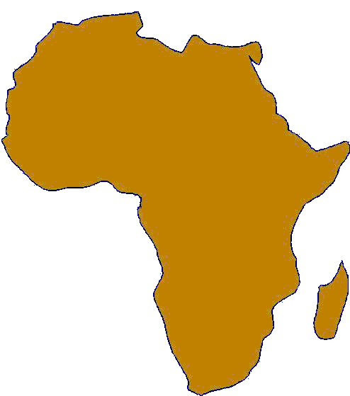

Corpus Christi Africa Fund (CCAF)

Should you wish to make a fresh or further donation to the Corpus Christi Africa Fund please complete the section below. If you wish the donation to be given under Gift Aid, and have not already completed a Gift Aid form, please complete the Portsmouth Diocese Form (copies can be found at the back of the Church). Donations and forms can be left in the dedicated box at the back of the Church or handed in at the Parish Office.

Thank You

Name of Donor:

Address of Donor:

Amount of Donation:

If you Gift Aid to Corpus Christi, please enter your Gift Aid Number or tick the “YES” box | YES NO

*If you would like to Gift Aid your donation, please complete a Gift Aid Declaration form and return to Parish Office. (Forms can be found at back of church)

Please make cheques payable to Corpus Christi Africa Fund

